CMPE-491

High Level Design Report

MAI Therapist

Gülden Ünal

Project Supervisor:

Prof.Dr. Tolga Kurtuluş Çapın

Hatice Esra Yılmaz

Renas Barış Özkal

Uğur Kellecioğlu

Contents

1. Introduction 3

1.1 Purpose of the System 3

1.2 Design Goal 3

1.2.1 Reliability 3

1.2.2 Simplicity and Usability 3

1.2.3 Efficiency 4

1.2.4 Portability 4

1.2.5 Maintainability 4

1.2.6 Accuracy 4

1.3 Definitions, Acronyms and Abbreviations 4

1.4 Overview 5

2. Proposed Software Architecture 5

2.1 Overview 5

2.2 Subsystem Decomposition 6

2.3 Hardware/Software Mapping 8

2.4 Persistent Data Management 8

2.5 Access Control and Security 9

2.6 Global Software Control 9

2.7 Boundary Conditions 10

2.7.1 Initialization 10

2.7.2 Termination 10

2.7.3 Failure 11

3. Subsystem Services 11

3.1 Client Query System 11

3.1.1 Presentation 12

3.1.2 Controller 13

3.2 Server (AWS Cloud) 14

3.2.1 Logic 15

3.2.2 Pipeline 15

3.2.3 Modules 16

4. References 17

# 1. Introduction

Understanding your client is the key point of a therapy session. To understand and interpret correctly, therapists should be able to read the actions and emotions of their clients. This is something that they need to improve to be successful. To get better at reading emotions and understanding people, they need time, trial and error, and lots of practice.

Also, during sessions, important points may be overlooked, or therapists may need an opinion to see if they are thinking right. The stress of thinking that they missed something, or they do something wrong may affect the therapists next sessions.

MAI Therapist is here to help therapists about these issues. With its feature of analyzing emotions, gestures and facial expressions, MAI Therapist will help its users to understand their clients better. With our system, therapists will hand in an analysis of the sessions. Which can be used by therapists to improve or correct their approach.

## 1.1 Purpose of the System

The main purpose of the system is to help therapists in analyzing their clients. MAI Therapist aims to analyze emotions, gestures, facial expressions. With using the app, at the end of the therapy session, therapists will have an analysis that shows how their client react in specific conversation. This analysis will help the app users to improve their approaches and allows them to see the important points they missed.

## 1.2 Design Goal

In order to produce a working and successful system, it should have some properties. here are some of main properties that we decided MAI Therapist should have:

### 1.2.1 Reliability

Therapy helps people and can change their lives. Since it’s an important job what’s therapists are doing, the system they use should be reliable with the analyzes that it makes or the safety of the information.

### 1.2.2 Simplicity and Usability

Product or system interfaces should not be unnecessarily complex. It should be designed to be easy for users to understand and use. A simple and intuitive user interface enables users to operate products and systems quickly and effectively, increasing satisfaction and productivity.

### 1.2.3 Efficiency

This allows therapists to efficiently review sessions and identify areas for improvement. The system must be fast, handle large amounts of data, and be able to handle multiple sessions simultaneously. Designed for efficiency helps therapists save time and improve effectiveness.

### 1.2.4 Portability

Since the system can have users using different platforms, it must be cross platform (desktop, mobile, iOS, android etc.)

### 1.2.5 Maintainability

If there is a problem with one part of the system, it shouldn't affect other parts of the system. This is important so that the quality of service remains high as more modules are added.

### 1.2.6 Accuracy

Since the user will use it for a promised purpose, the system should fulfill its functional and non-functional requirements.

## 1.3 Definitions, Acronyms and Abbreviations

Therapy (psychotherapy): The treatment of mental health problems by talking with a therapist

Session: A period of time that is spent during the therapy

Client: A client refers to the device or web browser that is used to access and interact with the application over the internet that is used by the users.

AWS Cloud Services: Amazon Web Services (AWS) is a cloud computing platform that offers a wide range of services, including computing, storage, networking, database, analytics, machine learning, security, and more. These services can be used individually or combined to build and deploy applications and websites, store and analyze data, and manage and secure resources.

Therapist (psychotherapist): A specialist who treats a particular type of illness or problem, or who uses a particular type of treatment

Analysis: The detailed study or examination of something in order to understand more about it; the result of the study

Interpret: to decide that something has a particular meaning and to understand it in this way

## 1.4 Overview

MAITherapist is a web application which is designed especially for analyzing patient emotions of psychologists through therapy session video recordings. The psychologists are supposed to record the session by camera and upload the videos to the system. Then the system makes emotion analyses, turns it to written format and combines with the session transcript. Then, the final report can be viewed and downloaded by the user. The video recordings, transcripts and analysis are stored in AWS cloud to be viewed later, but the videos are deleted after 30 days. Besides them, there is a patient list of the psychologist, and detailed information about each of them.

The application consists of a client web interface for the users, and AWS cloud as backend for data storage and processing. In the client application, firstly there is a homepage that can be seen by everybody. There are other pages such as “about”, “pricing”, “contact” etc. as well. The users need to log in to the system in order to access the main features. If they are not registered in the system, firstly registration is made by using the sign up button. Otherwise, the login page is used by the login button. After logging in, they can view and manage their patients and information about them, or upload a session video of a related patient.

For the patient information, the user creates new patient information or updates the existing one. After saving it, it is sent to the backend to store in the DynamoDB database located in the AWS cloud.

For the video recordings, after uploading them, they are sent to the AWS Rekognition for emotion detection. Then these videos are kept in AWS S3 storage service. Also, the transcript of the video is generated and it is combined with the emotions that belong to the related time period. The result is stored in DynamoDB with the related patient data. End of the process, the report is sent back to the client application. After that, the user is able to see or download it.

# 2. Proposed Software Architecture

## 2.1 Overview

The MAITherapist system software architecture is a comprehensive document that describes the layout and component parts of the system. It acts as a blueprint for the design and development of the system, directing the team's technical choices and ensuring that all of the system's components function properly.

The software architecture contains details about numerous classes and modules discovered during the project's analysis phase. To make the system simpler to comprehend and use, these classes and modules—which serve as the system's building blocks—are arranged logically and hierarchically.

Software architecture defines the structure and organizing principles of the system by describing the relationships between subsystems and the technical choices made up to this point. This covers the technologies and frameworks employed in the system's development, as well as the design patterns and best practices that were used.

The software architecture gives the development team a roadmap and specifies classes and modules for implementation, ensuring that all required parts are present. By offering this level of detail and direction, the software architecture helps the MAITherapist system's development and deployment go smoothly.

## 2.2 Subsystem Decomposition

To achieve effective design and development for MAITherapist web application, it will be splitted into several subsystems based on functional and non-functional requirements besides technical considerations. Each of these subsystems will be responsible for specific tasks and functions. Subsystems are going to work together and provide a cohesive and efficient overall system.

**Front-end subsystem** will be in charge of the User Interface of the MAITherapist. It'll provide a user interface that is easy to use. We'll use Nuxt 3 built on a javascript framework Vue.js to implement server-side rendering. The application will provide a smooth and responsive experience for users. Front-end module will handle all engagement with the user. It'll communicate with the backend subsystem via APIs and represent the changes to users. AWS Amplify will also be used by the front-end subsystem to make it easier to integrate AWS cloud services, such as authentication, authorization, and data storage. Through APIs, it will communicate with the backend subsystem and manage all user interactions, including input and output. Through AWS Cognito, user authentication and authorization will be managed.

**Backend subsystem** will be responsible for the business logic and handle the data management. This subsystem consists of AWS cloud services, which are Lambda for functionalities, DynamoDB for database and S3 for storing static files, in order to fully scalable and well founded infrastructure for the system. This system will provide APIs to speak with the front-end subsystem and other external systems as well. It'll make sure the integrity and security of the data we store in the system.

**The security subsystem** is in charge of the web application's security and privacy, which includes data encryption, access controls, and user authentication and authorization. To offer strong security measures and guard against unauthorized access, it will integrate with AWS Identity and Access Management (IAM).

**The monitoring and logging** **subsystem** will be in charge of keeping track of the web application's performance and availability as well as gathering and storing logs for troubleshooting and analysis. With real-time visibility and insight into the web application's behavior provided by AWS CloudWatch, the team will be able to quickly identify and resolve any potential problems.

**The therapy analysis subsystem** will be in charge of using AWS Rekognition to analyze the therapy sessions in order to draw conclusions and spot trends. In order to enhance the therapeutic process and support wise decision-making, it will give therapists and patients data and reports.

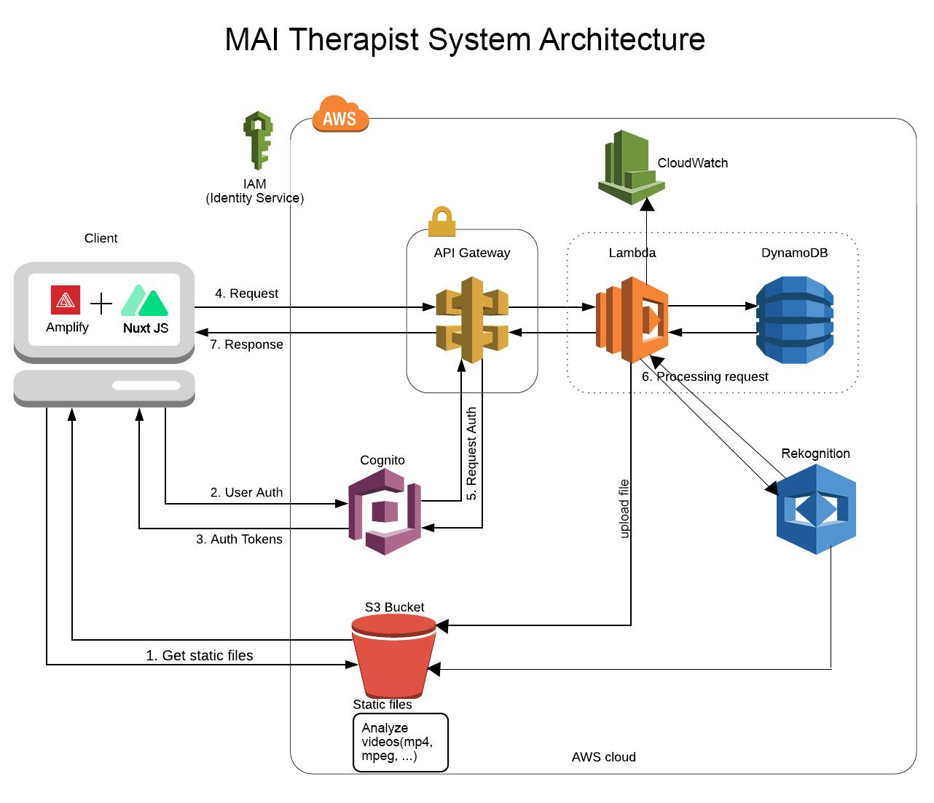

## 2.3 Hardware/Software Mapping

AWS S3: This service will be used to store and access user data, such as notes from therapy sessions and analysis findings.

User data, such as patient lists and analysis results, will be stored using the AWS DynamoDB service.

AWS Lambda: This service will be used to carry out the AWS Rekognito-based analysis of therapy session records.

For the web application's user authentication and authorization, AWS Cognito will be used.

To make the development and deployment of the web application easier, AWS Amplify will be used.

AWS CloudWatch: This service will be used to keep an eye on the performance and availability of the web application and the services that are connected to it.

The web application will manage access to the various AWS services it uses by using the AWS Identity and Access Management (IAM) service.

AWS API Gateway: This service will be used to create, publish, and secure APIs for the web application.

Nuxt.js: This framework will be used to build the server-rendered components of the web application using Vue.js.

## 2.4 Persistent Data Management

We'll be utilizing a mix of Amazon DynamoDB and Amazon S3 for persistent data management.

The documentation of therapy sessions and the findings of the analysis produced by Amazon Rekognition will both be stored in DynamoDB. Each record in a DynamoDB table that stores the records of therapy sessions will correspond to a single session. The name of the patient, the date and time of the session, and any notes or observations made by the therapist will all be attributes of the table, with the session ID serving as the primary key. An additional DynamoDB table will be used to store the analysis results produced by Amazon Rekognition. This table's primary key will be the session ID, and its attributes will include the analysis results and any pertinent metadata.

The video recordings of the therapy sessions and any accompanying paperwork or media files will be kept on S3. S3 offers a dependable, expandable, and safe storage option for these files. We will also use Amazon CloudFront, a content delivery network (CDN), to deliver the video files to users with low latency in order to maximize their performance.

We will use AWS Identity and Access Management (IAM) to regulate access to the DynamoDB tables and S3 bucket in order to guarantee data security and integrity. The data won't be accessible to anyone besides authorized users like administrators and therapists.

The performance and availability of the DynamoDB tables and S3 bucket will also be monitored using AWS CloudWatch, and alerts will be set up for any potential problems. AWS X-Ray will also be used to track requests and troubleshoot any data management system problems that may occur.

## 2.5 Access Control and Security

We will use Amazon Cognito for user authentication and AWS Identity and Access Management (IAM) for access control to ensure the security and privacy of the therapy session records and analysis results.

User account creation, management, and the procedure for verifying users' identities when they access the application will all be handled by Cognito. Access to the application and viewing the analysis and therapy session records will only be available to authenticated users.

The DynamoDB tables and S3 bucket that house the session logs and analysis results will be protected by IAM. IAM will enable us to specify which users or groups have access to which resources and at what level (e. g. read-write, read-only, or both). This will guarantee that only authorized users can access the data and that they can only carry out the authorized tasks.

We will also use Amazon Amplify to safeguard against widespread web vulnerabilities like cross-site scripting (XSS) and cross-site request forgery (CSRF), as well as to secure the communication between the web application and the backend services.

Last but not least, we will use AWS CloudWatch to keep an eye out for any potential problems with the security and access control systems and to set up alerts if necessary.

## 2.6 Global Software Control

We'll be utilizing a number of AWS services for global software control to make sure the web application is scalable, dependable, and responsive.

The web application or other AWS services will trigger events, and Amazon Lambda will be used to carry out backend logic in response. We won't have to provision or manage servers in order to respond to these events with code thanks to Lambda. This can enable us to easily and quickly scale the application to accommodate demand.

Amazon CloudWatch will also be used to set up alerts for any potential problems as well as to track the application's availability and performance. This will enable us to spot issues early on and fix them before they negatively affect the user experience.

Finally, in order to track requests and troubleshoot any application problems that may arise, we will use AWS X-Ray. With the help of X-Ray, we will have a thorough understanding of the request path and be able to spot issues early and fix them.

We can make sure that the web application can support a large number of users and requests without any downtime or performance issues by using these services for global software control.

## 2.7 Boundary Conditions

### 2.7.1 Initialization

During the initialization phase, first of all internet connection is required since the connections and necessary operations are performed through the internet.

When entering the web application client, the application will connect to the DynamoDB and S3 bucket to store the therapy session records and analysis results. It will load the list of authorized users from Cognito to make sure that only these users can log into the system. Also, it will load necessary configuration values and settings from a configuration file stored in S3, and necessary libraries and dependencies required by the application.

Then, to access the accounts users need to log into the system by their email and password. In this step, authentication will be made by Cognito. If the user does not exist, s/he must register to the system using the client. This process is made through the sign up button that opens the registration form. In the login page, if authentication is failed due to giving user data in the wrong way there is a warning about that. After logging to the system successfully, the user can reach the related content.

### 2.7.2 Termination

The user can log out of the application when s/he wants. However, if there is a process that is not completed yet such as uploading a video, waiting for the analysis result etc. there must be a warning message before termination.

If termination is made, the system shall close the connection to the DynamoDB and S3 bucket, save necessary data or state to DynamoDB and S3, and release resources that are no longer needed such as open connections.

### 2.7.3 Failure

If there is a failure in the system, the system shall try to save the latest data, log the error to a log file stored in S3, notify the appropriate parties such as developers if necessary, about the failure via email or SMS. Also the system shall attempt to recover from the failure by re-initializing any affected components or services if possible, otherwise it will shut down.

Moreover, since the internet connection is required for the application, lack of connection can be one of the main factors that cause failure.

# 3. Subsystem Services

## 3.1 Client Query System

The Client Query System subsystem is a user interface that allows the client to search and browse through their therapy sessions.

It is implemented using a web-based interface that the client can access from any device with an internet connection.

The client can enter keywords or use filters to find specific moments or topics in the sessions.

The subsystem will then retrieve the relevant video segments and transcriptions from the server and display them to the client.

The subsystem may also include additional features such as the ability to annotate or highlight specific segments of the video or transcript, or to save notes or observations about the session.

It may also include integration with the MAI Therapist Analysis subsystem, allowing the client to see the analysis results for specific segments of the session.

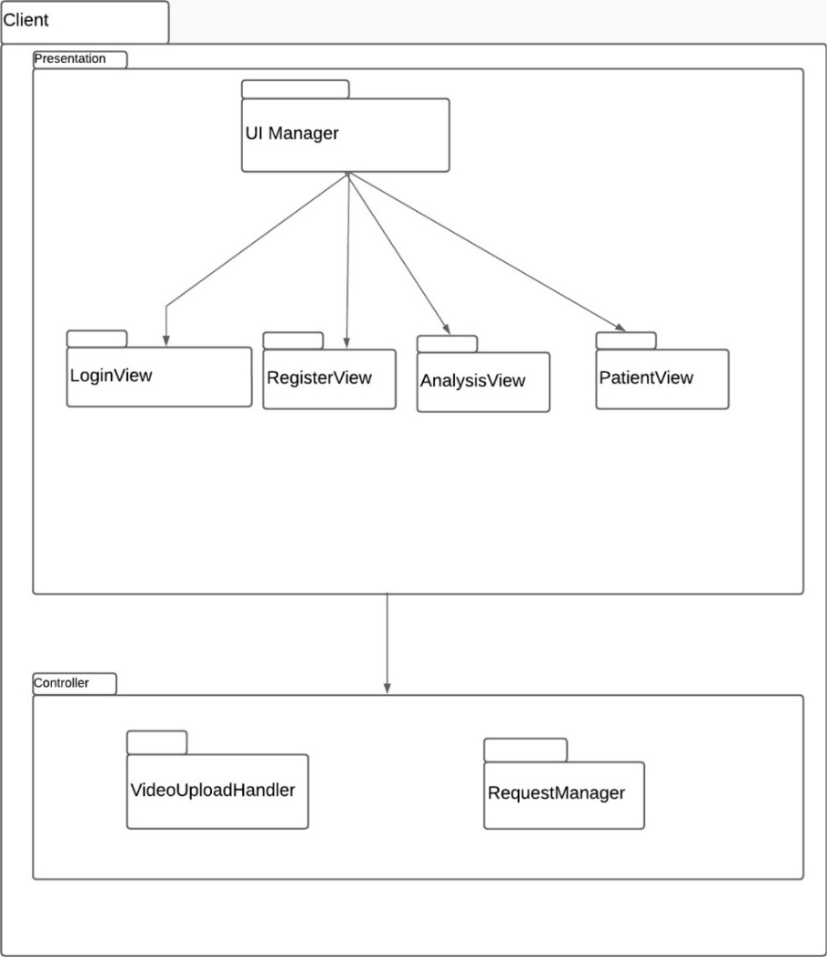

## 3.1.1 Presentation

The Client presentation layer is the interface through which the client interacts with the therapy system. It is responsible for displaying the therapy sessions and analysis results to the client and facilitating communication with the therapist.

UI Manager: The UI Manager is the top-level component of the presentation layer, responsible for managing the overall layout and navigation of the client interface. It will handle tasks such as displaying the various views (LoginView, RegisterView, AnalysisView, PatientView) and managing transitions between them.

LoginView: The LoginView is the view that is displayed to the client when they first access the system. It allows the client to enter their login credentials (username and password) and authenticate with the Server subsystem.

RegisterView: The RegisterView is the view that is displayed to the client when they need to create a new account on the system. It allows the client to enter their personal and contact information and create a new account.

AnalysisView: The AnalysisView is the view that is displayed to the client when they want to review and analyze their therapy sessions. It displays the video and transcript of the session, as well as any associated analysis results from the MAI Therapist Analysis subsystem. The client can use this view to search for specific moments or topics in the session, or to view the session in its entirety.

PatientView: The PatientView is the view that is displayed to the client during the therapy session. It displays the video and audio streams from the therapist, as well as any messaging or communication features that the therapist has enabled. The client can use this view to interact with the therapist during the therapy session.

## 3.1.2 Controller

The Client controller layer is the component of the client subsystem that manages the communication between the presentation layer and the Server subsystem. It is responsible for handling requests from the presentation layer, interacting with the Server subsystem to retrieve data and perform actions, and then updating the presentation layer with the results.

VideoHandler: The VideoHandler is a component of the controller layer that is responsible for managing the video and audio streams during the therapy session. It will handle tasks such as starting and stopping the streams, adjusting the volume and quality of the streams, and handling any errors or issues that may arise.

RequestManager: The RequestManager is a component of the controller layer that is responsible for managing requests from the presentation layer to the Server subsystem. It will handle tasks such as authenticating the client, sending and receiving data from the server, and handling any errors or issues that may arise. The RequestManager will use secure protocols and techniques such as encryption and secure socket layers to protect the data as it is transmitted between the client and server.

# 3.2 Server (AWS Cloud)

The Server subsystem is the central hub of the therapy system, responsible for hosting and managing the various components of the system, including Client subsystems.

In this implementation, the Server subsystem will be hosted on the Amazon Web Services (AWS) cloud platform. This will provide a scalable, reliable, and secure infrastructure for hosting the therapy system.

The subsystem will be implemented using a combination of AWS services and software (operating system, web server, database) that work together to provide secure access to the therapy sessions and analysis results.

The subsystem is responsible for managing user authentication and authorization, ensuring that only authorized individuals can access the system and view sensitive information. It will use secure protocols and techniques such as encryption and secure socket layers to protect the data as it is transmitted between the client and server.

The subsystem is also responsible for managing data storage, backup, and recovery for the system. It will use AWS services such as Amazon S3 and Amazon RDS to store and manage the therapy sessions and analysis results, and will ensure that backup copies are made in case of data loss or corruption.

The subsystem may also include additional features such as load balancing and scalability, which will be provided by the AWS cloud platform. This will ensure that the system can handle large numbers of users and sessions without performance degradation.

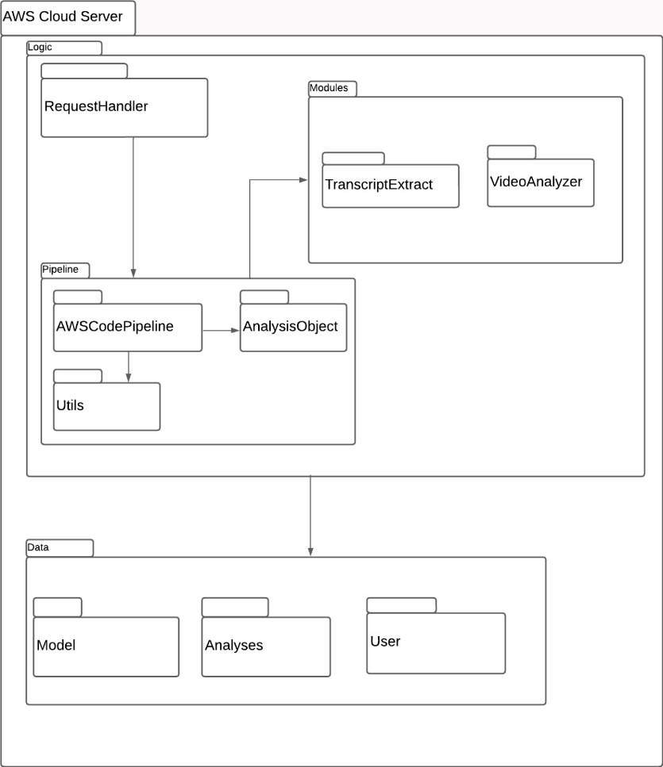

# 

# 3.2.1 Logic

The Server logic layer is the component of the Server subsystem that handles the processing and management of the therapy sessions and analysis results. It is responsible for interacting with the various components of the system and performing the necessary actions to store, analyze, and retrieve the data.

Pipeline: The Pipeline is the top-level component of the logic layer, responsible for managing the flow of data through the various components of the system. It will handle tasks such as routing data to the appropriate module for processing, scheduling tasks, and handling errors or issues that may arise.

Modules: The Modules are the components of the logic layer that perform specific tasks or functions related to the therapy system. These may include tasks such as data storage, analysis, or retrieval. Each module will be responsible for a specific aspect of the system and will interact with the other modules as needed to perform its tasks.

Request Handler: The Request Handler is a component of the logic layer that is responsible for handling requests from the Client subsystem. It will receive requests from the Client subsystem, pass them to the appropriate module for processing, and then return the results to the Client subsystem. The Request Handler will use secure protocols and techniques such as encryption and secure socket layers to protect the data as it is transmitted between the Client and Server subsystems.

# 3.2.2 Pipeline

AWS CodePipeline: AWS CodePipeline is a service provided by Amazon Web Services (AWS) that can be used to automate the build, test, and deployment of applications. It can be used to create a continuous delivery pipeline that enables rapid and reliable delivery of changes to the therapy system.

AnalysisObject: The AnalysisObject is a data structure that represents an analysis result from the MAI Therapist Analysis subsystem. It will contain the raw data from the analysis, as well as any additional metadata or metadata.

Utils: The Utils subclause is a collection of utility functions that can be used by the other components of the pipeline. These may include functions for tasks such as data formatting, error handling, or logging.

# 3.2.3 Modules

TranscriptExtract: The TranscriptExtract module is responsible for extracting transcriptions from the therapy sessions. It will process the video and audio data from the sessions and use speech-to-text technology to generate transcriptions of the conversations. The transcriptions will be stored in a suitable format for further analysis or review.

VideoAnalyser: The VideoAnalyser module is responsible for analyzing the therapy sessions and generating insights and recommendations for the therapist. It will use machine learning algorithms and natural language processing techniques to identify patterns and trends in the conversations, and will generate reports and summaries of the analysis results that the therapist can use to inform their treatment approaches.

3.2.4 Data

The Server data layer is the component of the Server subsystem that is responsible for storing and managing the data used by the system. It consists of a number of data models and collections that represent the different types of data used by the system.

Model: The Model is the base data structure that represents a single record or document in the system. It may include fields such as an ID, timestamp, and metadata, as well as the actual data being stored.

Analyses: The Analyses collection is a collection of AnalysisObject data structures, representing the analysis results from the other subsystem. It will store the raw data from the analyses, as well as any additional metadata or metadata.

User: The User collection is a collection of data structures representing the user accounts on the system. It will store information such as the user's name, contact information, and login credentials.

## 4. References

1)<https://docs.aws.amazon.com/rekognition/latest/dg/stored-video-lambda.html>

2)<https://hackernoon.com/image-analysis-using-aws-rekognition-via-lambda-function-hvq3uvy>

3)<https://docs.aws.amazon.com/toolkit-for-visual-studio/latest/user-guide/lambda-rekognition-example.html>

4)<https://docs.aws.amazon.com/rekognition/latest/dg/images-lambda-s3-tutorial.html>

5)<https://medium.com/serverless-transformation/what-a-typical-100-serverless-architecture-looks-like-in-aws-40f252cd0ecb>

6)<https://medium.com/aws-serverless-microservices-with-patterns-best/aws-serverless-architectural-patterns-and-best-practices-d2d446375924>